Software requirement specification (SRS) document template



Project name:



Date:



Version:



By:



Revision history Version

Author

Verson description

Date completed

Review history Approving party

Version approved

Signature

Date

Approval history Reviewer

Version reviewed



Signature



Date

Table of contents

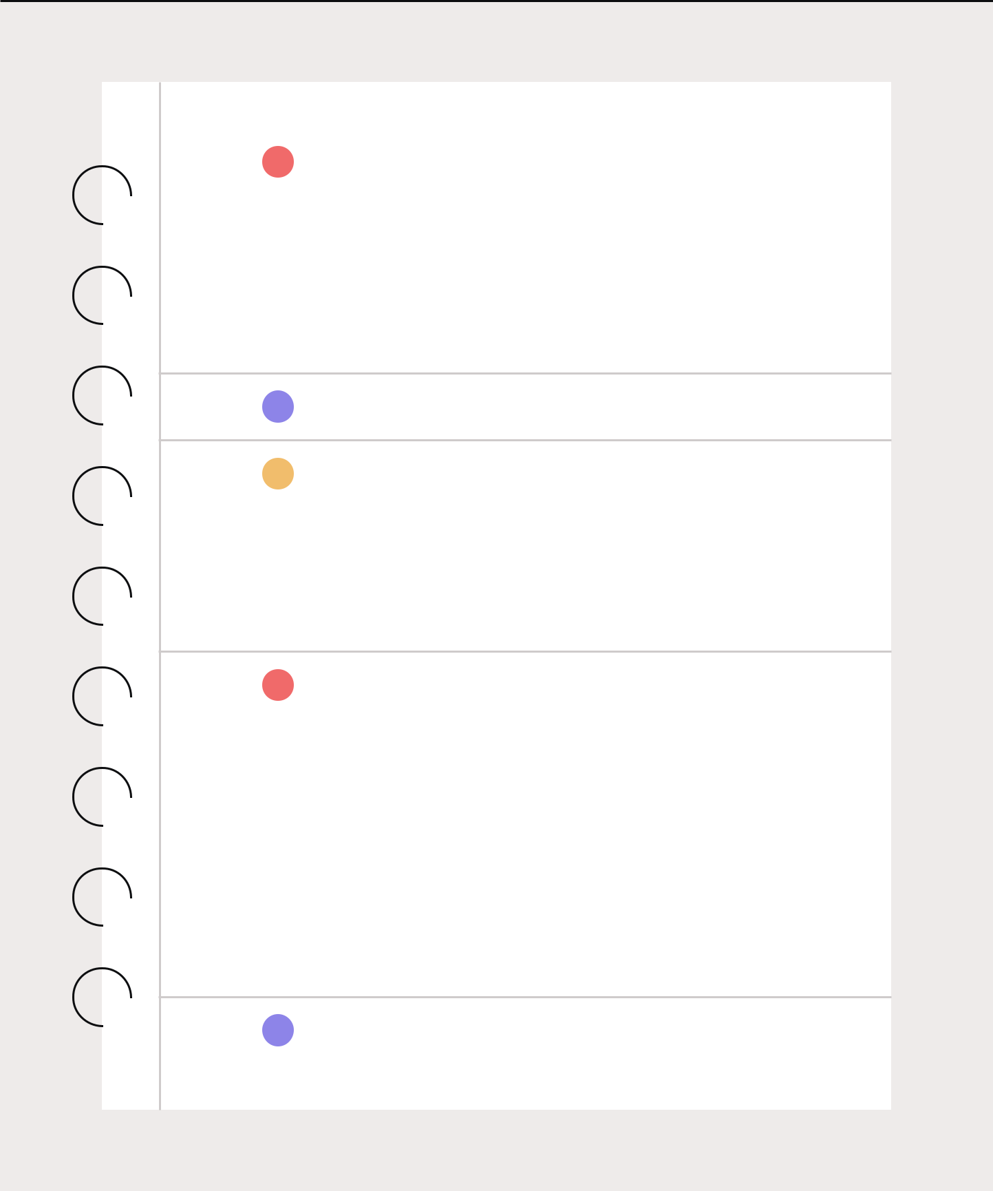

1. Introduction

1.1 Product scope

1.2 Product value

1.3 Intended audience

1.4 Intended use

1.5 General description

1. Functional requirements
2. External interface requirements

3.1 User interface requirements

3.2 Hardware interface requirements

3.3 Software interface requirements

3.4 Communication interface requirements

1. Non-functional requirements

4.1 Security

4.2 Capacity

4.3 Compatibility

4.4 Reliability

4.5 Scalability

4.6 Maintainability

4.7 Usability

4.8 Other non-functional requirements

1. Definitions and acronyms



1. Introduction



Describe the purpose of the document.



1.1 Product scope List the benefits, objectives, and goals of the product.



1.2 Product value Describe how the audience will find value in the product.



1.3 Intended audience Write who the product is intended to serve.



1.4 Intended use Describe how will the intended audience use this product.

| 1.5 General description | Give a summary of the functions the software would perform |
| --- | --- |
|  | and the features to be included. |
|  |  |



1. Functional requirements



List the design requirements, graphics requirements, operating system requirements, and constraints of the product.



1. External interface requirements



| 3.1 User interface | Describe the logic behind the interactions between |
| --- | --- |
| requirements | the users and the software (screen layouts, style guides, etc). |
|  |  |

| 3.2 Hardware interface | List the supported devices the software is intended |
| --- | --- |
| requirements | to run on, the network requirements, and the communication |
|  | protocols to be used. |
|  |  |

| 3.3 Software interface | Include the connections between your product and other |
| --- | --- |
| requirements | software components, including frontend/backend |
|  | framework, libraries, etc. |
|  |  |

| 3.4 Communication | List any requirements for the communication programs |
| --- | --- |
| interface requirements | your product will use, like emails or embedded forms. |
|  |  |



1. Non-functional requirements



| 4.1 Security | Include any privacy and data protection regulations |
| --- | --- |
|  | that should be adhered to. |
|  |  |

| 4.2 | Capacity | Describe the current and future storage needs |
| --- | --- | --- |
|  |  | of your software. |
|  |  |  |
|  |  |  |
| 4.3 | Compatibility | List the minimum hardware requirements for your software. |
|  |  |  |
|  |  |  |
| 4.4 | Reliability | Calculate what the critical failure time of your product |
|  |  | would be under normal usage. |
|  |  |  |
|  |  |  |
| 4.5 | Scalability | Calculate the highest workloads under which your software |
|  |  | will still perform as expected. |
|  |  |  |
|  |  |  |
| 4.6 | Maintainability | Describe how continuous integration should be used to |
|  |  | deploy features and bug fixes quickly. |
|  |  |  |
|  |  |  |
| 4.7 | Usability | Describe how easy it should be for end-users to use |
|  |  | your software. |
|  |  |  |



4.8 Other List any additional non-functional requirements.



1. Definitions and acronyms

